Q: how can artists and designers justify using the crowd to generate their work?

# Index

## I. Introduction

## II. Why is it worth talking about the crowd?

## III. Case Studies

## A. Casey Pugh: Star Wars uncut

## B. Daniel Eatock: Contributions

## C. Yayoi Kusama's Obliteration Room

## IV. Analysis

## V. Conclusion

# I. Introduction

The justification for the work of creative practitioners relies on the interaction with the crowd. Designers and artists aim to engage their audience and bring them new information. This information can be straightforward like the cover of a birthday card or charity's appeal. It can also be self-reflexive, the kind of information that highlight aspects of a collective abilities and can help us learn new things about ourselves.

In this dissertation I will discuss works of three artists and designers who put their will aside and allow the crowd to generate content independently. I will show how using the product of the crowd work is justified by its eventual reinterpretation and rerelease into the crowd. I will discuss if giving credit to the different contributors helps resolve the question of authorship that may rise in some of these works. To conclude, I will try to determine if these work allow the crowd to become more aware of its own potential and make it wiser.

To demonstrate my subject matter I have made the decision to release the design of this dissertation away from me. Instead, I will invite members of the crowd (anyone who could read my text) to design different segments of this work.

I plan to provide each contributor with the template of a single page. He or she will be provided with a maximum of 300 words of this text and a few basic guidelines for designing their page. I plan to impose minimal restrictions for these contributions. The restrictions I impose will serve only to make the production of pages easier and to produce some level of visual relationship between all the pages of the work. Once I hold sufficient amount of contributions I intend to bring them together and produce a final peace – my dissertation and the crowd’s collective design.

Finally, In accordance with my conclusions I will make the final result of the process available to all.

# II. Why is it worth talking about the crowd?

## The crowd has power – it can change the world.

The first thing that attracted me to the subject of crowds was a Ted talk by Alexis Ohanian (Ohanian, 2009). In this presentation Ohanian described how the users of his co-created website, reddit, affected the results of Greenpeace's poll to name a whale (the name they voted for was ‘Mr splashy pants’). The reason for the poll was part of an effort to interfere with the Japanese government’s plans to hunt Humpback whales for research purposes (Know Your Meme, 2011). The redditors (users of reddit) debatably cared about this and instead saw this as a game where the goal was to make the organization do something they did not mean to do. The other names offered by Greenpeace were ethereal sea gods’ names, and at first the poll’s deadline was extended so that the reddit disturbance would blow away. Ultimately this resulted in enough media coverage that made the Japanese government change its decision (News.bbc.co.uk, 2007). Further to that, Splashy won the competition.

### What is reddit

According to the site’s Frequently Asked Question Page (Reddit.com, 2013):

‘reddit is a source for what's new and popular on the web.  
Users like you provide all of the content and decide, through voting, what's good and what's junk.  
Links that receive community approval bubble up towards #1, so the front page is constantly in motion and (hopefully) filled with fresh, interesting links.’

Using it felt like I was making a difference and I became attracted to the thought that I could, one day, find myself instrumental in positively affecting and promoting causes I deem worthy; but doing so without too much effort or commitment on my side.

My first impression of such an event unfolding in real time was Hurricane Sandy and the way individuals offered to help in any way they could (Reddit.com, 2008). Examples[1] include people offering to come and help or letting strangers know they had electricity so they could charge their electrical devices. By ‘upvoting’ comments of people who volunteered help I increased the chances those who needed assistance seeing these offers. I may have been in another country and had no practical way of helping anyone directly affected, however, I felt I was helping in a real way. 

Figure reddit.com front page screen shot (Reddit.com, 2013)

## Today we are always a part of the crowd. We do not always understand how it works, but it does.

For the purpose of this work ‘crowds’ are groups made of individuals, which have some form of real time (instantly or near-instantly transferrable) communication between all of them. Until recently that implied that they needed to be in relatively close geographical proximity. Today our information is constantly being released into a crowd; it is the online crowd that I refer to. Our mobile devices and online activity see to that. Often this happens even without us being conscious of that fact. So even when we don’t think about it, we help form it.

Next on my reading list was ‘Here Comes Everybody’ by Clay Shirkey.

Shirkey explains how the Internet and its modes of communication function. His main point is that ‘more is different’. The sentiment, taken from the world of physics, expresses the notion that it would be impossible to tell how an individual will behave in a group when they have only been observed in isolation[2]. Similarly, observing the conduct of groups numbering in the dozens does not provide insight into the behaviour of groups numbering in the thousands. This is why we struggle to understand how a large crowd is affected by our actions.

Earlier I claim that crowds are people who are linked together via means of communication. Shirkey describes the connection between communication and crowds by linking amateur content generation and social relationships(Shirky, 2009)[3]. Finding people (who we share an interest with) is very easy nowadays. If something we have to say is important to enough people, then our system of social connections will see it distributed like a ripple in a pond. On the other hand, that ‘wise crowd’ (a concept I explain shortly) will filter out any comments which only few have any interest in.

## What is a ‘wise crowd’ and how did this become important suddenly.

In ‘The Wisdom of Crowds’ by James Surowiecki the author tries to make sense of what makes large groups potentially superior to the individuals within it. He identified Diversity of [opinion](http://en.wikipedia.org/wiki/Opinion), Independence, Decentralization and Aggregation as the four characteristics essential for the ‘wise crowd’ (Surowiecki, 2005). These are conditions, which our online social tools produce at all times.

Suroweicki mentions Gustave Le Bon, a 19th century thinker who famously wrote ‘The Crowd: A Study of the Popular Mind’. In it Le Bon proposed that crowds are to be viewed as singular units, rather than many separate individuals. Unlike Suroweicki he proposed that crowds have only the Intelligence and intellect shared between all of its members. In other words crowds act as a primitive human being would, compelled by instincts and prone to irrational senseless acts. He points out that individuals in a crowd do things they would never seriously contemplate on their own. Le Bon attributed these actions to several causes, amongst them a sense of invincibility lent to an individual by belonging to the crowd. His argument describes the individuals as hypnotized and the crowd the hypnotist. However, Le Bon could not have conceived an evolution to this phenomenon because sophisticated communication tools (such as mobile technology) did not exist in 1896.

We are becoming very connected, very quickly. If the crowd we form is wise then it wants the best for itself – the common best for all of us. By analysing our output and then re-releasing it we are giving it more information, thus helping to better the crowd. Why should we not, if we cannot avoid being a part of it anyway? It is like a single cell within a body that does what ever it can to help and improve the well being of the entire system.

The thing that baffled me the most was how could these tools for communicating on such a grand scale develop without me noticing every step of the way? These tools were developed for years but suddenly they are everywhere. Was it a gradual process or was there a key moment? I discovered what I believe to be the answer in Malcolm Gladwell’s book ‘The Tipping Point’, where he explains that more often than not, great change occurs near instantly when a critical point of saturation or exposure occurs. He demonstrated this effect with the example of water turning to ice:

‘Almost nothing had changed, in other words, yet and this was the amazing thing -everything had changed. Rain had become something entirely different. Snow! (p.13, Gladwell, 2000)’

Clay Shirkey identifies the tipping point for the crowd sometime in 2002 (p.153 Shirky, 2009). At some point that year, the physical location of information became irrelevant and the rate in which we could transfer it became instantaneous.

## Being a part of the crowd makes sense as a strategy for humanity.

Shirkey’s final point in ‘Here Comes Everybody’ is that the political value of the increased ease of self-expression is indisputably positive (Shirky, 2009)[4]. It is hard to decide if being able to share videos of unfolding disasters from ground zero and having tools such as Wikipedia benefits us more than terrorists hacking activity puts us in danger. However, it is widely accepted that freedom is something we desire for our society. Thus, having the ability to express ourselves freely stands positive.

In his book, The Black Swan, Nassim Nicholas Taleb proposes that what we do not know is much more important than what we do know. ‘Think of the terrorist attack of September 11, 2001: had the risk been reasonably conceivable on September 10, it would not have happened’ (Taleb, 2007). Taleb tries to make the case for how increased availability of data is detrimental to our ability to make the right choices if we attempt to do it alone[5]. This brings us back to Suroweicki’s proposal – if there is too much information for one person to make sense of, let the crowd have a go. According to Shirkey, we are better prepared for the task as a society than ever before.

Our society has changed drastically over a very short period. We now possess better and faster modes of communication. The improved communication makes us capable of things we have yet to realise.

The crowd we form today is a powerful super organism. Its embrace on our lives and our returned embrace suggests it holds the mystery of humanity’s future. In 2002 owing to superior modes of communication we were able to isolate the SARS virus in only 5 months (p.158, Surowiecki, 2004), a feat which is credited to the collaboration between labs rather than to one particular researcher. Yet, even if you put aside what crowds are able to achieve, the fact remains that they are centred on the individuals comprising them. Today we belong to a crowd nearly all the time, and when we do so its benefits go to you and me as individuals first of all.

# III. CASE STUDIES

## A. Casey Pugh: Star Wars uncut

### Casey Pugh

Casey Pugh describes himself as a ‘creative technologist’. His career began in 2007 when he joined the team behind the website Vimeo. In his time working for the online film sharing service, view was instrumental in developing their unique video player (Zebo, 2010). Later he went to work for Boxee – an Internet TV service and has since quit it and co-created VHX, a film distribution service which aims to let go makers distribute their work straight to fans, cutting distribution fees.

Star Wars uncut is in essence the original ‘Star Wars: A New Hope’ film, which Pugh has split into 473 15-second clips. The twist is that in Pugh's remake of the film every 15 seconds have been made remade, filmed or animated by a different person. Star Wars Uncut is a fan feature film made on a massive scale. It is available to watch online, for free (starwarsuncut.com).

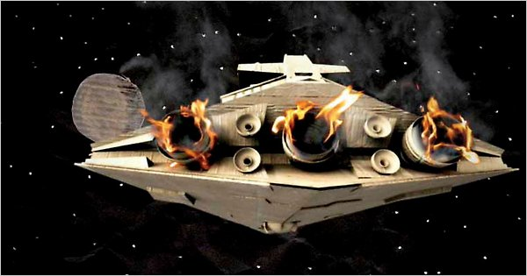

Figure Still from Star Wars Uncut (Star Wars Uncut, 2012)

### The process

Pugh recognised that his first challenge would be to get the word of his work out into the crowd (Zebo, 2010). He began that process by posting about the project in his blog, and asking his friends to share and tell others of his efforts. According to him ‘they re-blogged it and it just created a viral, chain effect.’ (Zebo, 2010).

The next priority was to make participation as easy as possible. He designed a gallery where the scenes appear in thumbnail format and allowed users to reserve their preferred scenes. Once a user reserves the scene, they had 30 days to submit a 15 second remake for that segment.

The responses for the project were very positive, with all the scenes claimed in the first three days after the site's first release (the big interview, 2009). You suggested to participants that they should keep the first and last seconds of their contributions relatively true to the original film to allow the film to run more smoothly. Otherwise, there were encouraged to produce whatever interpretation of their scenes they desired. By the end of this process, you received almost 1000 submissions. 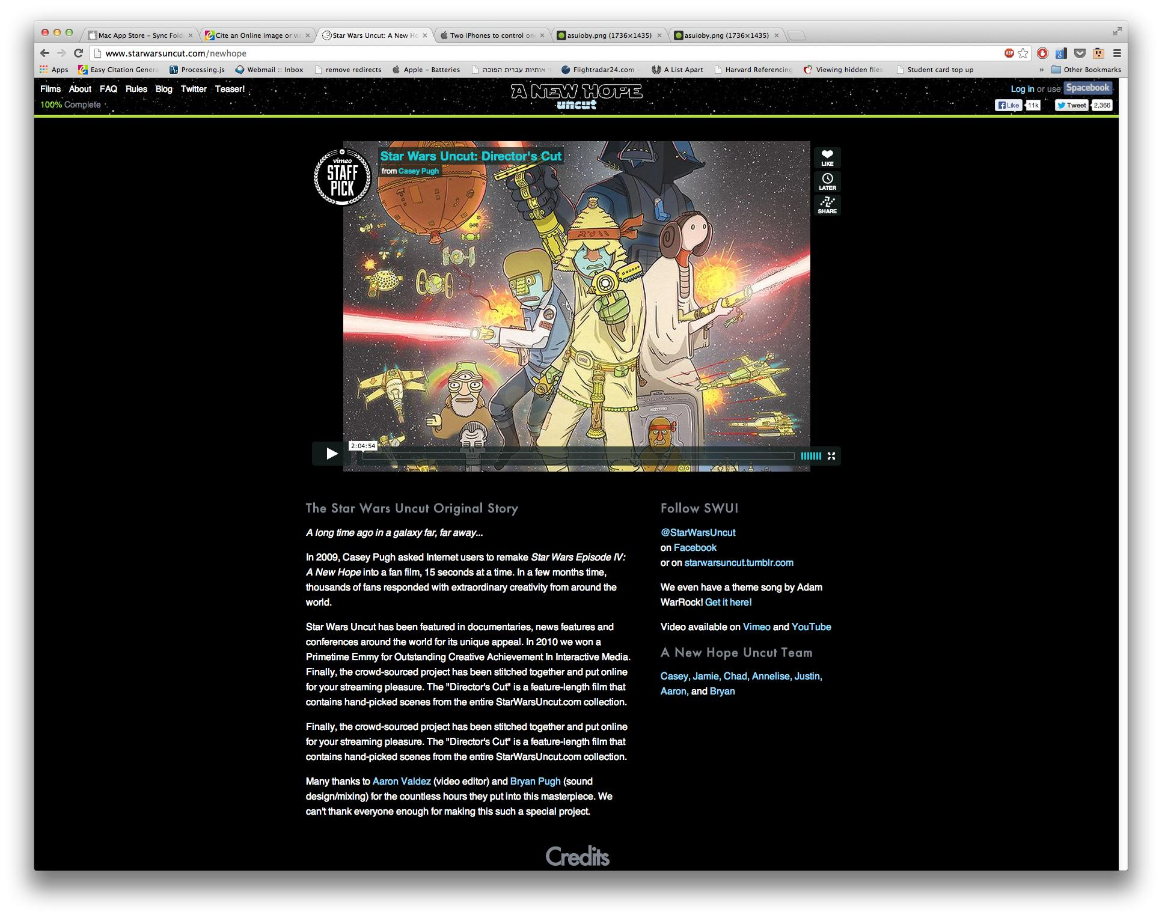

Figure Screen Shot from Star Wars Uncut website (Star Wars Uncut, 2013)

### End result

In an article titled The Work of Art in the Age of Mediated Participation: Crowdsourced Art and Collective Creativity, Ioana Literate describes the result of Casey Pugh's work as ‘recreating the famous world of Luke Skywalker and Princess Leia with everything from cats to fingers to costumed children to salt and pepper shakers.’ (Literate, 2012. p.23). The end result is a wonderfully coherent ‘mash up’, as she describes it.

In 2010 Pugh attended the Emmy awards ceremony where he won the award in the interactive media category. Upon his nomination he released a statement saying ‘the real stars other fans and contributors’(Stelter, 2010). Indeed, today on the website there is a list crediting all the participating users by their Vimeo usernames.

The director’s cut featured on Vimeo is interesting, because despite the name which suggests Pugh's editorial input, his real part in that version is programming system which chooses the most popular scenes based on a number of Vimeo ‘likes’ and compiles them seamlessly to form the two-hour film.

The next instalment in the Star Wars Uncut saga is now in production, but there is no expected time of release. 

Figure Star Wars Uncut promotion (Star Wars Uncut, 2013)

## B. Daniel Eatock: Contributions

### The creator and the work

‘Using my background knowledge from working as a graphic designer, I employed a rational, logical and pragmatic approach when making work’ (eatock.com, n.d).

Daniel Eatock is a UK based visual artist and graphic designer. One of his better-known designs are the original logo for Channel four’s Big Brother.

Eatock's works usually have a strong, clear concept, which inspires the final outcome. The way he achieves this is by creating a set of rules, which are used to direct a kind of experiment. He rarely analyses the results, instead he publishes them on his website (www.eatock.com) in an on going process.

In his book published in 2008, he describes the website as ‘a box where the most recent project is on top and the oldest one on the bottom’ (Eatock, 2008). The website format allows everyone to see Eatock's past work which is finished, as well as works in progress. Those ‘uncompleted’ works fall under the artist’s category of participatory projects. It is these kinds of projects that I will focus on in this study.

### The process

The projects under Eatock's ‘participate’ that I will be focusing on are those, which require the participants to produce a visual art outcome. These works displayed as a series of thumbnail galleries, the images enlarge when clicked. Under each photo or illustration Eatock names the person who submitted it. At the top of these gallery pages there is a description of the work. In ‘Holley Portraits’ (Eatock, n.d), a project that has concluded in 2012, the artist provides a back-story, which explains that the work is inspired by a friend’s work. He then proceeds to instruct would-be participators in how to contribute. The aim of the work is to produce a self-portrait, which consist of a written description of the subject in the shape of his or her own thumbprint. The result is a gallery of self-portraits, on first impression similar to each other, yet in fact completely individual. It himself did not submit his version for this work.

In ‘No photo’, a more recent on going project, Eatock provides no back-story. The top of the page feature the instructions ‘Photograph the signs that tell you not to’(Eatock, n.d). It seems that eatock does not want to impose a deeper meaning to this project, instead he allows the witty nature of the instructions, and the subsequent submissions (credited photos of many ‘please do not take pictures’ signs) to be their own justification. The gallery is a bizarre and ironic sight. It presents the viewer with an assortment of photograhs, which theoretically were never supposed to be taken.

Eatock's site features three completed ‘participated’ works and six on-going ‘participate’ projects. Some, like ‘Lens Touch’, which calls for submissions of photographs featuring a finger touching the lens, seem whimsical and maybe even pointless. Yet, the fact that they do attract the crowd’s participation lends them a kind of meaning, which is deeper than is initially apparent. This deeper meaning is hard to define, but it does well in drawing users to revisit the website and follow Eatock's work. The artists work truly involve the crowd the exposes a large part of his personal (if public) work process. 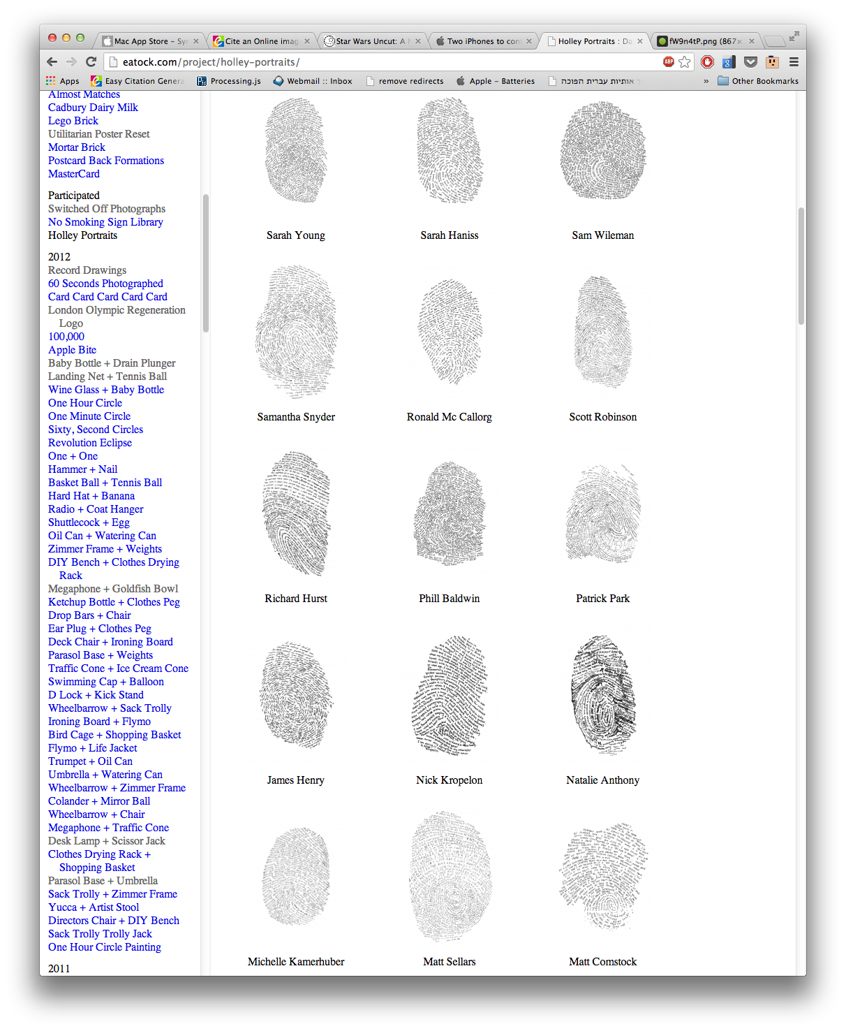

Figure Screen shot of Daniel Eatock's Holley Portraits gallery (Eatock, 2013)

### End result

The front page of Eatock's website features two pictures, one titled ‘picture of the week’, the other ‘thank you picture’. Both change weekly, end the picked some interesting visual element, like cars with different coloured doors, street signs, which have been vandalised in creative ways. The difference is that he posts the first picture the latter is submitted to him by a stranger. Eatock's online platform represents how deeply he appreciates the value of participation. The works are often not finished as such but in some respects they needn't be. They serve as a kind of mirror of what participators have achieved and what they can do collaboratively. His minimalistic instructions also highlight how easy it is to work together. The message his work seems to advocate is that all we need is a platform for sharing and a simple idea.

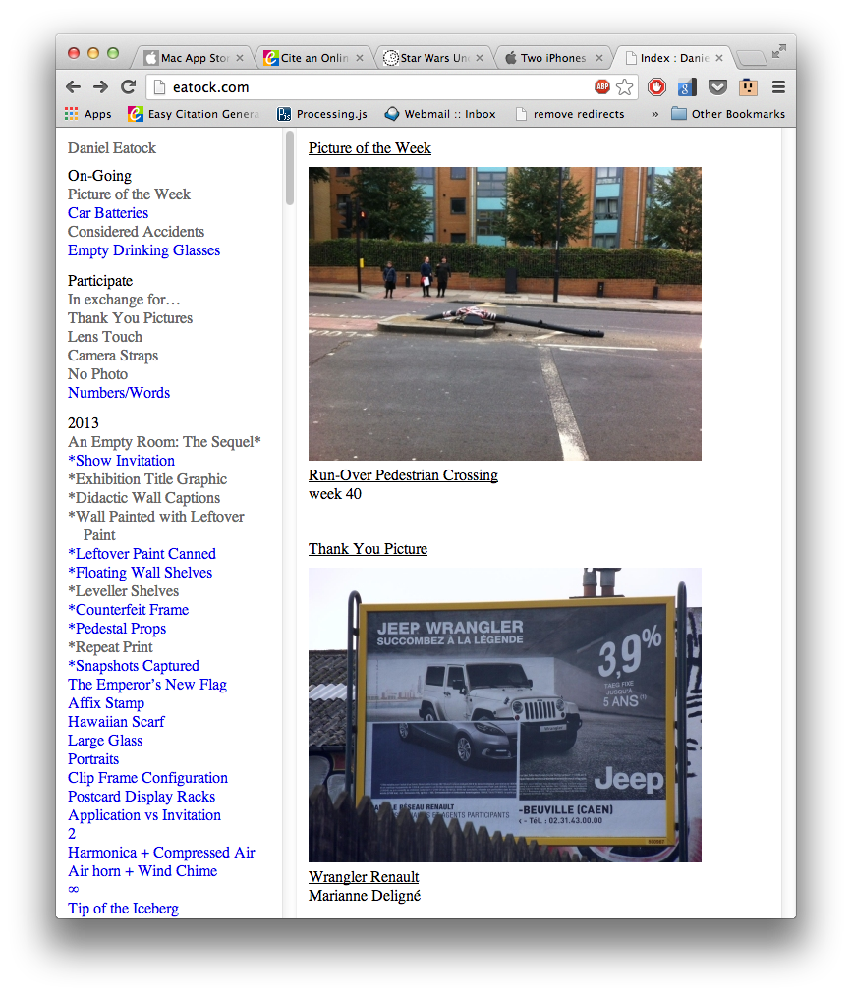

Figure www.eatock.com fromt page screen shot (Eatock, 2013)

Ea

## C. Yayoi Kusama’s Obliteration Room

### Obliteration as liberation

Yayoi Kusama was born in Japan 1929 (Grant, 2009). Despite Japan being a country of origin, she rejects her associations to its art scene and influences. Instead, she gives credit to America for forming her identity as and artist (Pilling, 2012). Kusama lived in New York for more than 15 years, and in that time her works were compared with those of Andy Warhol, Mark Rothko and Roy Liechtenstein.

Kusama's work is in its essence the artist's response to an on going mental in illness, which has affected her life since childhood (Greer, 2009). Nearly all her works feature masses of polka dots, which according to her represent visions and hallucinations she has. The dots also represent her way of dealing with the anxieties she experiences owing to her mental state (Pilling, 2012). “I make them and make them and then keep on making them, until I bury myself in the process. I call this process ‘obliteration’”.

### The Obliteration Room

The Obliteration Room 2011 is a large-scale recreation of the artist’s work for the Kid’s portion of the Asia Pacific Triennial of contemporary art 2002(Visualarts.qld.gov.au, 2002). For the second iteration of this piece, Kusama has set up a typical Australian domestic environment (Ellwood, 2011) inside the Gallery of modern Art, Brisbane (the Guardian, 2012). What sets this pseudo-room apart is the way Kusama had it set up.

‘At the start of the project, this room was completely white – white ceiling, white floor, white walls, white furniture.  People come in, they are given a sheet of coloured stickers in different sizes, which have been produced specially for the project and in accordance with the artist’s specifications; her choice of colour, her choice of finish, and her choice of size.  And then everybody is invited to place the stickers anywhere they like in the room, according to any pattern, any idea they have, anything they like they can do with the stickers.’ (Tate.org.uk, 2012)

The installation was principally aimed at children (Jobson, 2012), but it ended up seeing many adult contributors (the Guardian, 2012). Kusama has incorporated the crowd in some of her previous works (Ellwood, 2012). Yet, the obliteration room is a first work in which she invited the crowd to actively produce her ‘trademark’ polka dots. 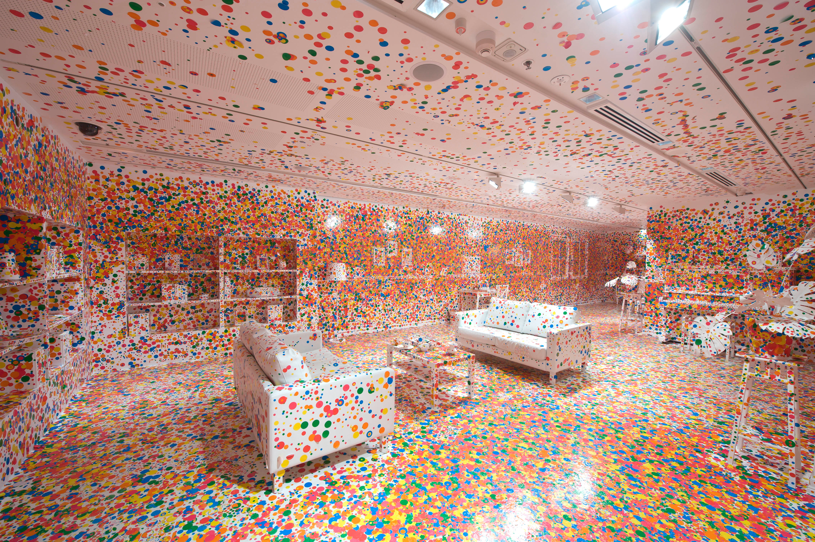

Figure The obliteration room by Yayoi Kusama (Harth, 2012)

### Legacy

Yayoi Kusama is very concerned with her legacy and in a recent interview she expressed the hope that this legacy will be the pursuit of an end to war and appreciation of life (Pilling, 2012). It seems rather fitting then, that in this state of her life she makes work that enables a young generation to become creative and engage with her work without her physical presence being a necessity. 

Figure 8 Yayoi Kusama at Victoria Miro Gallery. Art Basel Miami Beach (galleryIntell, 2012)

# IV. Analysis

## Social Capital, a platform and reward as key ingredients for crowd sourced work.

Casey Pugh's Star Wars uncut, Daniel Eatock's 'participate' works and Yayoi Kusama’s obliteration room have all successfully sourced creative production from many people who they do not know. When a group exhibits this kind of cooperation, it is down to a phenomenon called social capital.

Clay Shirkey explains that when a group trade on social capital, all members gain each other's favour (shaky, 2009 page 193). Social capital acts as the glue that enables cooperation, and bridges between individuals in heterogeneous groups (page 222). In all three case studies there is an element, which utilises an existing source of social capital. Star Wars, which was first released in 1977 (Vaux, n.d.), Has a large community of fans, which suggests a gradual buildup of social capital over the years. Star Wars uncut is an iteration of this social capital at work. Daniel Eatock's appeal, in a similar way, stems from his graphic designers/artist’s celebrity status - for individuals who are visual art students or amateur practitioners, the prospect of collaboration with an established artist is attractive. Kusama is using both the establishment where her work is presented and her reputation as a famous artist to attract participation from thousands of people (Ellwood, 2001).

Another thing all these works have in common is that they provide a setting for the work to be created. The Queensland's Gallery of modern Art enabled Kusama to create a physical platform where kids could play. The Internet, in both Eatock and Pugh's works provides a cheap and easy platform for people to get together.

But the question remains what could motivate individuals to participate in these works. It is not likely that they care about the success of the project before they invested any time in it. It is safe to assume however, that they care about their own reputation. An individual might feel cheated if they get nothing in return for their contribution. Yet if they can claim a part of a renowned artist's work they will gain positive reputation. Kusama's pre-claimed physical space ensures that contributions are immediately connected to her, and she provides all the necessary tools for participation (i.e. white room and special stickers)

Star Wars uncut and Eatock must step up and satisfy the contributors' expectation through an ongoing process. Imagine if you would, that you have just submitted a photo to Eatock's website or a 15 second film to Pugh's project. It is not until your work features on the Internet that you get your hard work's reward. In other words, the expectations that you take time and produce content is not reasonable unless you are promised that it will fit into a bigger picture. In both of these cases the lack of physical space would have been an insurmountable obstacle until the beginning of the century.

## The instigators of a crowd-sourced project win the title ‘hardest workers’, but they author the platform, not the contributions.

When an individual engages with one of these works, they are required to give at most 30 days to their contribution. By contrast, the party that initiated the process had to conclude it, and in most cases have engaged in a certain amount of moderation when the work was in progress. Pugh had to programed a player to stream the full version of Starwars Uncut (Zebo, 2010). While on Eatock’s website there is not ‘submit’ button, the designer single handedly uploads images he receives via his email. It is therefore important to note that the instigators are the ones who work the hardest individually and put the most individual effort into the work.

Yayoi Kusama has gone to the length of setting up a physical space and commissioning the right kind of stickers. All the involvement she requires is for kids to run around and make a mess, hardly a lot to ask of a child. It is easy therefore, to identify her as the author.

Pugh and Eatock require the participants to produce more. In contrast with stickers, we recognise that films and photographs have authors and that it is not acceptable to assume authorship of another's work. So adhering to society's standards, Pugh recognises himself and his team as the authors of 'Star Wars Uncut', but make it clear that they did not author the individual scenes that make it up. Eatock claims authorship of the 'Participate' projects as platforms, but he credits each contribution to an individual.

## Crediting contributions.

Judging by the level of effort required of participant in Star Wars uncut, it is my opinion that the directors cut should have identified which scene was created by whom. The credits appear in alphabetical order that, amongst other things, make contacting the individuals who contributed to the work quite difficult. The fact that those are Vimeo user names is not stated.

This point is important, because the three main authors of my case studies seem to have made the assumption that the contributors do not wish to be linked to their contributions, or be contacted directly through association to their contribution. Yet all three decided to provide and associate their own contact details with these works.

Why have they not offered the opportunity of exposure to the contributors? It seems an obvious act, but in none of my case studies were participants asked 'what credit would you like?' The answer to the question would ensure that whether they remained anonymous or fully identified, all the collaborators would have been satisfied.

## The Internet enables and preserves the information about these works.

Every time a work is produced as a result of cooperation it serves as a proof to the potential we have as a society. The Internet not only provides the means to facilitate such works. It also allows for the preservation of the information they produce. Therefore, these works, which strongly rely on the Internet, are a constant reminder of what has been achieved collectively. The text that describes them can be found by key terms using search engines. Even Kusama's work, which had its own physical platform, and did not originally depend on the Internet, has since been disassembled. Now, its existence is mainly confirmed by the Internet, which hopefully preserves its lessons as well.

## These works are created by wise crowds.

In order to determine if wise crowds make these works I will turn to the criteria James Surowiecki outlines in 'The Wisdom of Crowds' (Surowiecki, 2005) and see if they adhere to them.

### Diversity of opinion

All three works allow participators to have their own opinions of the process and no relevant information is withheld from them. So they can form independent judgments of it.

### Independence

Within the parameters of each project, individuals are allowed to decide on how to shape their own contributions.

### Decentralisation

In Star Wars uncut and 'Participate**'** there is ample opportunity for individuals to draw on local knowledge and their own specialisms. Kusama's work is geared towards children and is arguably restricting in that respect. However, it is impossible to say that it does not allow knowledge participators already have to affect how they contribute.

### Aggregation

In Star Wars uncut, the voting system determined which scenes were most popular and those were compiled into the aggregate, which in this case turned into the 'director’s cut' version (Pugh, 2012).

Daniel Eatock's website is itself the aggregate of the work. On his website the collective decision takes the shape of galleries where all the results can be seen side-by-side.

Kusama's room aggregates all the contributions.

## Engaging with these kinds of works makes us wiser.

The difficulty in determining what qualifies as wisdom in these cases is the lack of predetermined criteria for success or failure. As I pointed out earlier the artists have given up control of the final outcome, so it is irrelevant whether the results are aligned with their initial expectations.

The crowd's contributions to Pugh's work were all moving image pieces and they all relate to Star Wars. The contributions to Eatock's galleries are all photos or visual files with similar characteristics and Kusama's room includes only one kind of contribution. None of them have the equivalent of a pineapple found in a crate marked 'Oranges'. This is the evidence that intelligence is in play and not the result of erratic interaction. Finally, the fact that we can and are producing more of this kind of work means we form wise crowds more often. The longer, more often, we form a wise crowd, and the easier it is for us to form it, the wiser we become.

# V. Conclusion

We live in a highly connected environment, and create content constantly. Artists and designers who wish to take advantage of this phenomenon must offer something in return for the crowd’s participation. I have explained that social capital is a good indicator of probable cooperation. The ultimate part played by the initiator of the work is publishing the result. This final act gives meaning to the effort made by everyone else. By publishing the results as a final collaborative work they justify asking others to work for them. I have shown that when that work encompasses elements, which we recognise as intellectual property, they must be credited. I also suggested that the best way to validly produce the credit is by adhering to the contributors' wishes. I have shown that the Internet provides us with a record of past achievements, which allows us to analyse the results of our past efforts. Finally, I have linked the different attributes of my case studies to the characteristics of a wise crowd as described by James Surowiecki (p.10). Following from this, I have proposed that the intelligent way in which the eventual results are presented in these works is the best indication that we are learning to become a wiser collective.

As I have indicated earlier, it is just over a decade since our society entered a stage of increased connectivity. In this short time we have changed dramatically in how we interact, but we are like a growing adolescent that is only beginning to appreciate the full range of movement in his developing body. We test and try our social muscles and often make clumsy mistakes from which we learn to improve. A proof of this is the plethora of literature on the subject of marketing through social media. Writers have very mixed opinions of the users of such sites, from ‘Facebook users are very sophisticated’ (ReadWrite, 2011) to ‘Facebook users are on dope… They aren't attracted to advertisements’(Lannigan, n.d.).

These kinds of bewildered observations show our anxiety over the fact that we belong to a crowd of millions, if not billions. This phenomenon is unprecedented and we do not know how to deal with ourselves in this state. This is inspiring uncertainty and distrust in the new forms of communication which sustain the crowd’s existence. However, I have shown that through the purposeful engagement with our new capabilities we allow ourselves to grow aware and hopefully comfortable with our new abilities. To find comfort while dealing with the crowd, and to learn how to get what we want out of it is wonderful for us as individuals. What we must ask ourselves now is whether we can afford not to make use of these capabilities in order to deal with the challenges our society is facing today, and will face in the future.

1. Reddit’s user created area dedicated to hurricane Sandy related material http://www.reddit.com/r/sandy/search?q=if+anyone+needs&restrict_sr=on&sort=relevance&t=all
2. p.22: ‘…aggregations of anything from atoms to people exhibit complex behavior that cannot be predicted by observing the component parts. Chemistry isn't just applied physics–you cannot understand all the properties of water from studying its constituent atoms in isolation. This pattern of aggregates exhibiting novel properties is true of people as well.’ Clay Shirky, . Here Comes Everybody Power of Organizing Without Organizations (Hardcover, 2008). Edition. Psnguin Pr,2008.
3. p.83-84: ‘User-generated content isn't just the output of ordinary people with access to creative tools like word processors and drawing programs; it requires access to re-creative tools as well, tools like Flickr and Wikipedia and weblogs that provide those same people with the ability to distribute their creations to others. ... User-generated content is a group phenomenon, and an amateur one. When people talk about user-generated content, they are describing the ways that users create and share media with one another, with no professionals in sight. Seen this way, the idea of user-generated content is actually not just a personal theory of creative capabilities but a social theory of media relations’. Clay Shirky, . Here Comes Everybody Power of Organizing Without Organizations (Hardcover, 2008). Edition. Psnguin Pr,2008.
4. p.298: ‘The second argument on behalf of new capabilities for groups dispenses with descriptive value and instead concentrates on political value. In this view, the current changes are good because they increase the freedom of people to say and do as they like. This argument does not suffer from the problem of incommensurability, because an increase in various forms of freedom-especially in freedom of speech, of the press, and of association-is assumed to be desirable in and

   of itself. This does not mean there will be no difficulties associated with our new capabilities-the defenders of freedom have long noted that free societies have problems peculiar to them. Instead, it assumes that the value of freedom outweighs the problems, not based on a calculation of net value but because freedom is the right thing to want for society.’ Clay Shirky, . Here Comes Everybody Power of Organizing Without Organizations (Hardcover, 2008). Edition. Psnguin Pr,2008.
5. Part 2, INFORMATION IS BAD FOR KNOWLEDGE: ‘The more information you give someone, the more hypotheses they will formulate along the way, and the worse off they will be. They see more random noise and mistake it for information.’